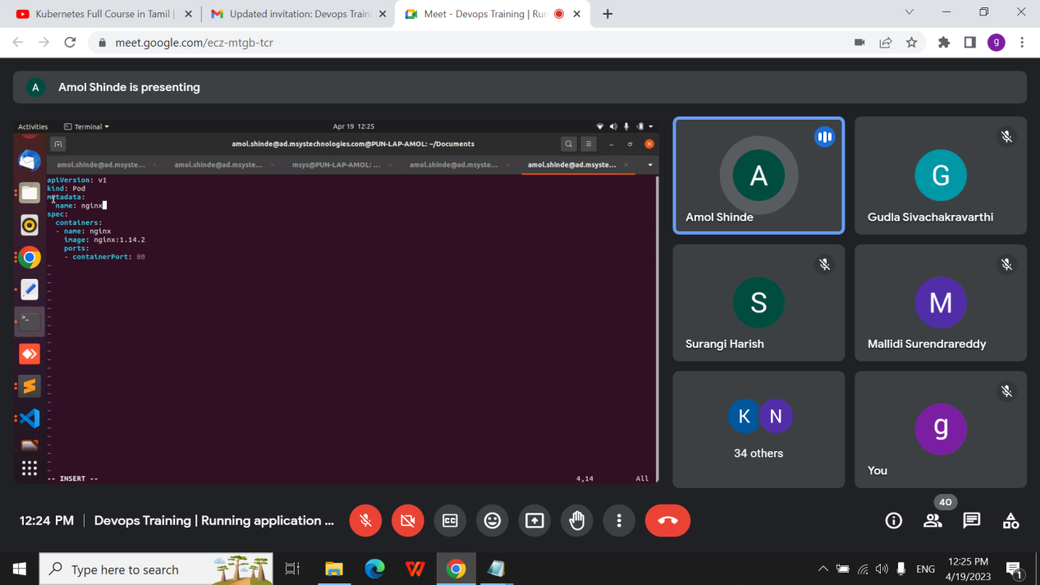

\

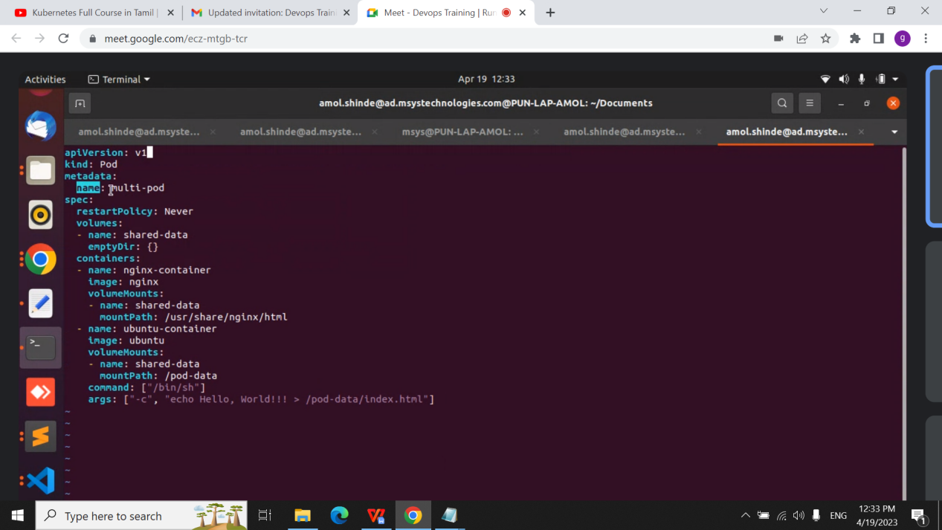

Dep

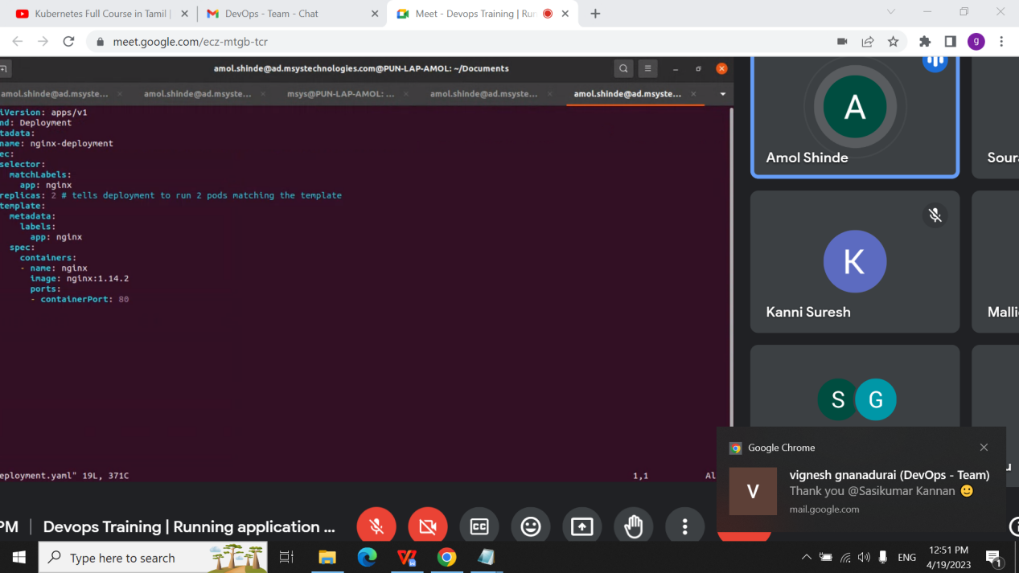

Secret;

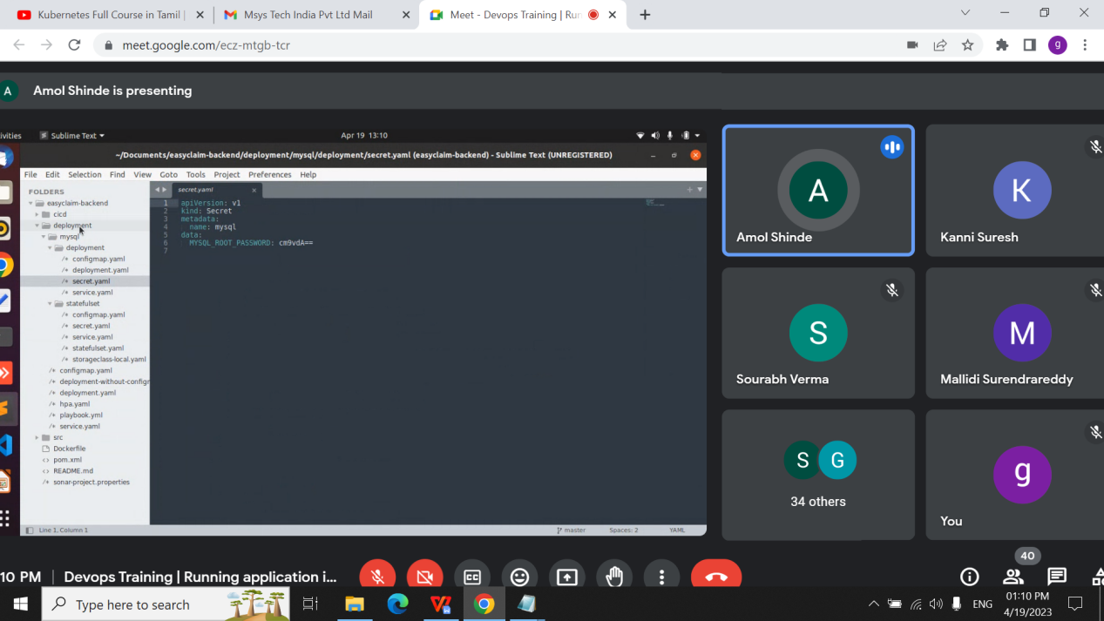

Configmap

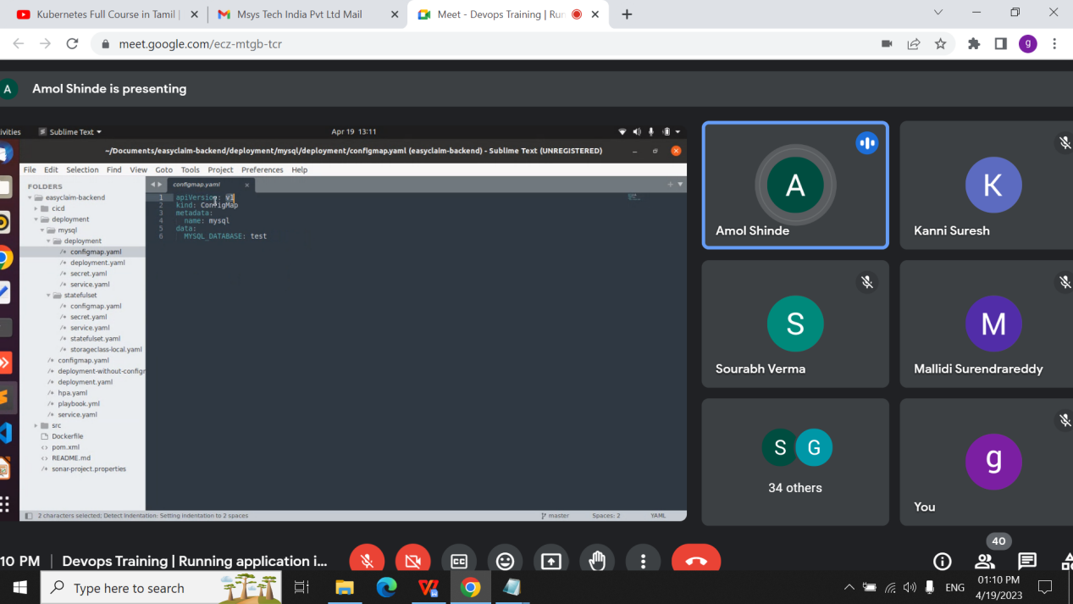

Combination of both

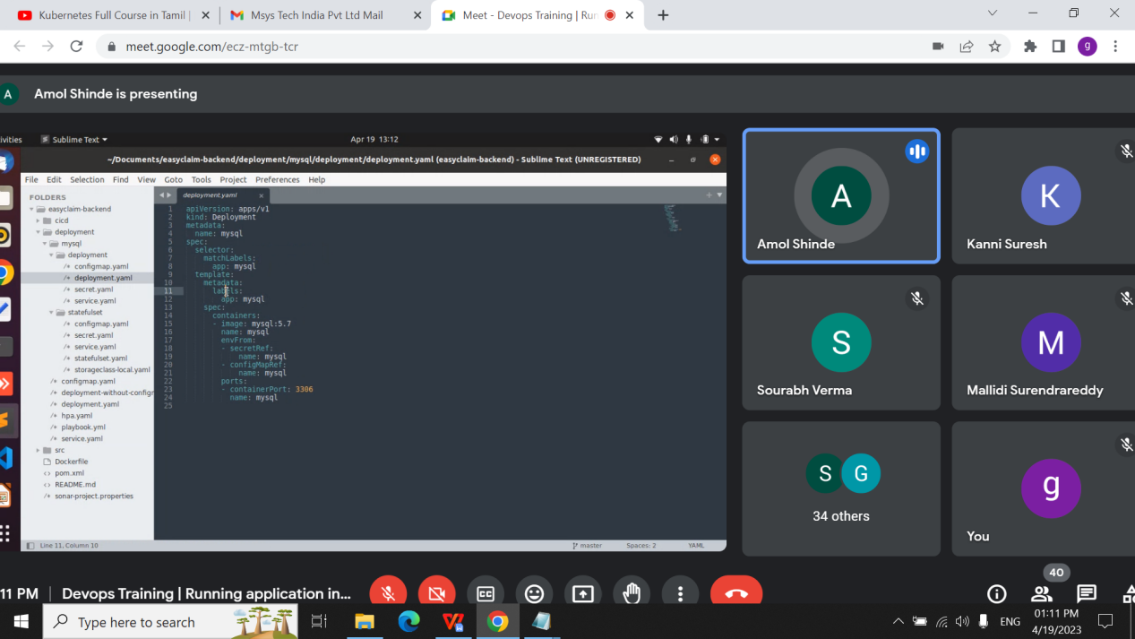

<https://minikube.sigs.k8s.io/docs/start/>

[https://drive.google.com/drive/folders/1FFQb0y0EKVpTBLo6EfV8kREdRqhcuV2j](https://drive.google.com/drive/folders/1FFQb0y0EKVpTBLo6EfV8kREdRqhcuV2j" \t "https://chat.google.com/u/0/_blank)